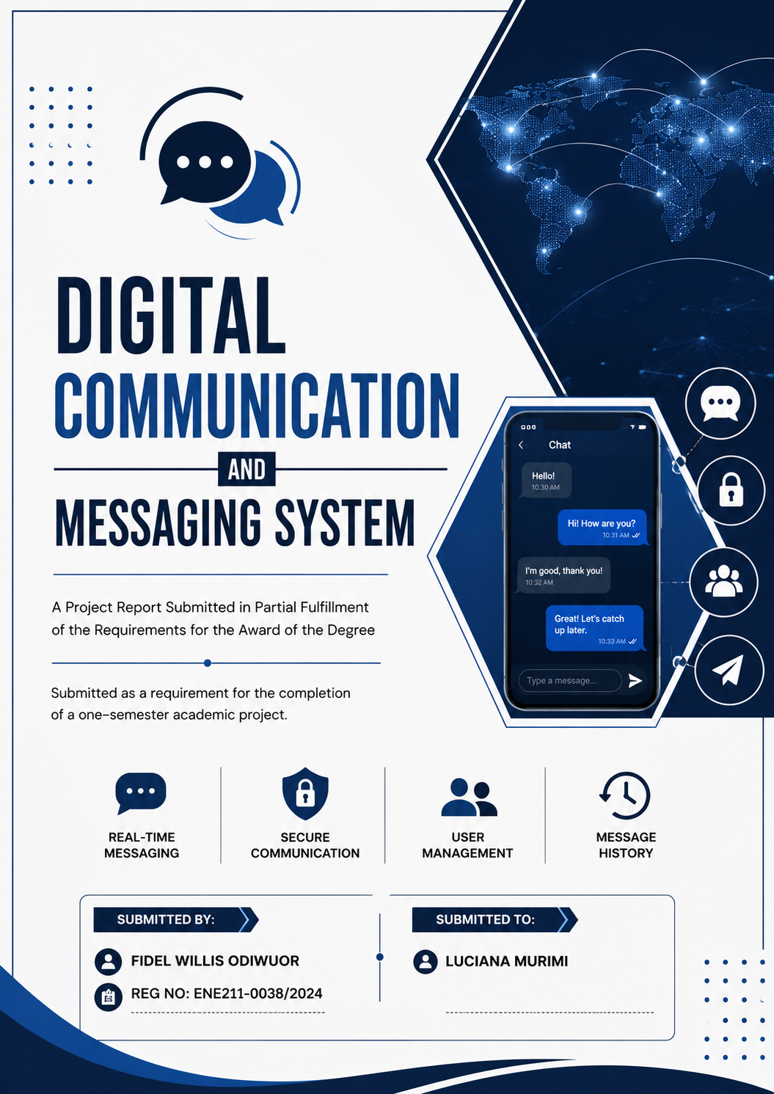digital communication and messaging system

1. Background of the Project
Communication systems have become an essential part of modern computing and daily life. Messaging applications are widely used in schools, organizations, and social platforms to facilitate the exchange of information in real time. As technology advances, software developers require programming techniques that improve software organization, maintenance, and scalability.
Object-Oriented Programming (OOP) is one of the most effective programming paradigms used in modern software development. OOP allows developers to organize software into objects and classes that represent real-world entities. Concepts such as encapsulation, abstraction, inheritance, and polymorphism make programs easier to manage, reusable, and more secure.
This project focuses on the development of a scalable Chat Application using the C++ programming language. The application is designed to simulate communication between users through a command-line interface. Users are able to register accounts, log into the system, send messages to other users, and view chat history.
The project demonstrates the practical implementation of Object-Oriented Programming concepts while providing a functional and user-friendly communication system.

2. Functional Requirements

Requirement | Description
User Registration | The system should allow new users to create accounts using usernames and passwords.
User Login | Registered users should be able to log into the system securely.
User Logout | Users should be able to log out of the application safely.
Send Messages | Users should be able to send messages to other registered users.
Receive Messages | The system should allow users to receive and view messages.
Chat History | The system should store and display previous conversations between users.
Menu Navigation | The application should provide a menu-driven interface for easier interaction.
Error Handling | The system should detect and handle invalid user inputs appropriately.
Data Storage During Runtime | The application should maintain user and chat data while the program is running.

3. System Design (Major Components)
The system design describes the major components of the chat application and their responsibilities. The application is divided into several classes to ensure modularity and maintainability.

User Class
Responsible for storing user information such as username and password. It also handles user authentication and account management.

Message Class
Responsible for creating, storing, and displaying messages sent between users. It manages message details such as sender, receiver, message content, and timestamp.

ChatSystem Class
Acts as the central controller of the application. It manages users, stores messages, handles authentication, and coordinates communication between users.

Main Interface Module
Provides interaction between the user and the application through menus and prompts. It allows users to navigate different features of the system.

4. System Functional Modules
The system is divided into different functional modules to improve organization and efficiency.z

Registration Module
Allows new users to create accounts by entering usernames and passwords. The module validates user information before registration is completed.

Authentication Module
Handles user login and logout operations. The module verifies whether the entered credentials match stored user data.

Messaging Module
Enables users to send and receive messages. The module manages message creation, delivery, and display.

Chat History Module
Stores conversations between users and allows retrieval of previous messages.

User Interface Module
Provides menus, prompts, and navigation features that allow users to interact with the application easily.

5. Data Description
The system uses different categories of data to manage users and communication.

5.1 User Data
Field | Description
Username | Unique identifier used by the user to log into the system.
Password | Secret credential used for user authentication.

5.2 Message Data
Field | Description
Sender | Username of the person sending the message.
Receiver | Username of the person receiving the message.
Message Text | Actual content of the message sent.
Timestamp | Time and date when the message was sent.

6. Conclusion
The Modular Chat Application demonstrates the practical implementation of Object-Oriented Programming concepts using C++. The project provides a structured and modular approach to software development through the use of classes and objects. Features such as user registration, authentication, messaging, and chat history management make the system functional and user-friendly.
The project also highlights how OOP principles such as encapsulation, abstraction, inheritance, and polymorphism can be applied in real-world applications. The system can further be improved by adding graphical user interfaces, databases, networking, and real-time communication features in future versions.

